BIT 4107 – Mobile Application Development
ENHANCED PROFESSIONAL STUDENT LOGBOOK

DUKASTOCK
B2B Mobile Marketplace — Connecting Wholesalers & Retailers in Kenya

Student Name | Eugene Goodness Ndungu

Admission Number | BIT/2025/69183

School / Faculty | School of Computing and Informatics

Programme | Bachelor of Science in Information Technology

Academic Year | 2026

Semester | Semester 2

Lecturer | ___________________________________

Phone Number | ___________________________________

GitHub Repository | https://github.com/jokacoded124/-dukastock

Test Device | Redmi Note 14 (Android)

Instructions

This logbook is used to document weekly learning activities, practical exercises, skills acquired, challenges encountered, solutions applied, and reflections. Students should complete all sections every week.

Each week contains the following sections:
- Practical Activities Undertaken — screenshots of actual work done
- Screenshots / Evidence Attached — insert real screenshots from your computer
- Tools / Software Used — list all tools used that week
- Personal Reflection — not more than 50 words

Note: Generic AI-generated reports without practical screenshots will not be accepted. All screenshots must show your own running system.

Table of Contents
Instructions 3
Table of Contents 4
Week 1: Introduction to Mobile Application Development 5
Practical Activities Undertaken 5
Screenshots / Evidence Attached 5
Tools / Software Used 9
Personal Reflection 10
Week 2: Mobile Development Environment — Firebase & Authentication 11
Practical Activities Undertaken 11
Screenshots / Evidence Attached 11
Tools / Software Used 13
Personal Reflection 13
Week 3: User Interface Design 14
Practical Activities Undertaken 14
Screenshots / Evidence Attached 14
Tools / Software Used 15
Personal Reflection 15

Week 1: Introduction to Mobile Application Development

Practical Activities Undertaken

- Installed Android Studio Panda 4 (2025.3.4 Patch 1) on Windows 11 including Android SDK, Build Tools 37, and Android Emulator
- Installed Git for Windows and configured global user name and email for GitHub integration
- Created a GitHub account and set up the DukaStock repository with Flutter .gitignore and README
- Cloned the DukaStock GitHub repository to G:\Projects\-dukastock on the local machine
- Downloaded Flutter SDK 3.44.0-stable (Windows x64) from the official Flutter archive and extracted to G:\flutter
- Created the DukaStock Flutter project using the flutter create command with Android-only platform flag
- Opened the project in Android Studio and configured the Flutter SDK path
- Created and configured a Pixel 6 Android Virtual Device with API 37 (Android 17.0 CinnamonBun)
- Customized main.dart — changed app title to DukaStock, theme color to green, added Welcome to DukaStock! text
- Ran DukaStock app successfully on the Pixel 6 emulator
- Committed and pushed all Week 1 code to GitHub (53 objects pushed)

Screenshots / Evidence Attached

Screenshots Attached: Yes

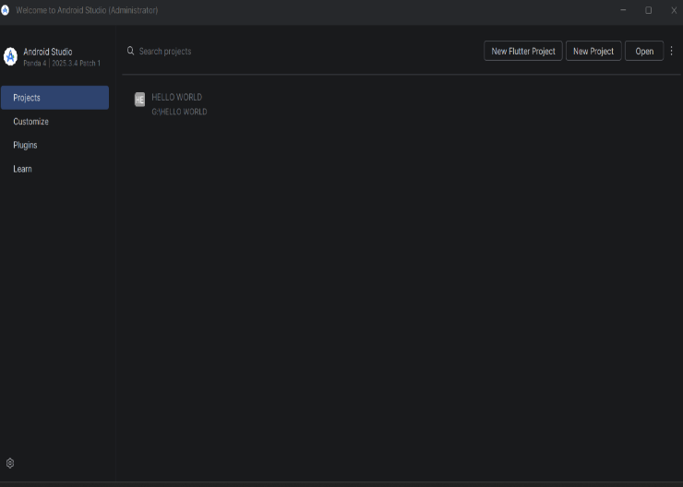
Screenshot 1: Android Studio welcome screen after installation

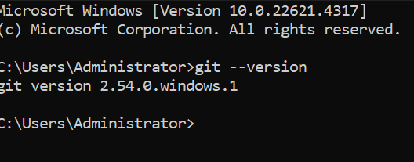

Screenshot 2: git --version output in Command Prompt

📸 INSERT SCREENSHOT HERE
Screenshot 3: GitHub DukaStock repository page

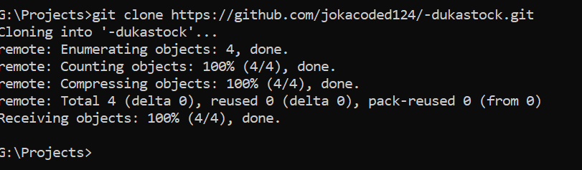
Screenshot 4: git clone and git status output in Command Prompt

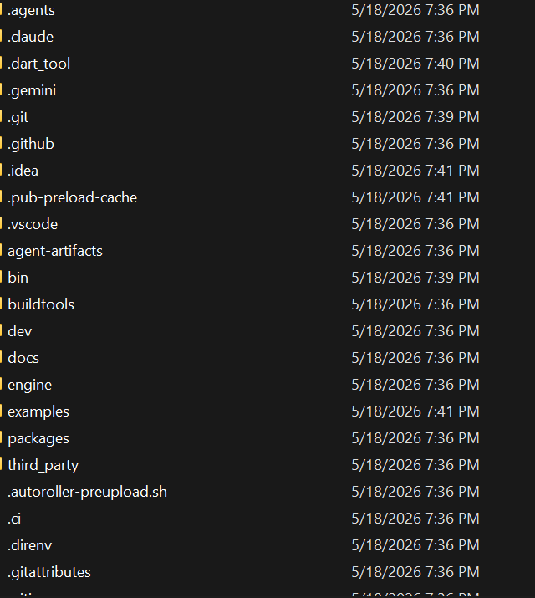

Screenshot 5: Flutter SDK folder extracted at G:\flutter

📸 INSERT SCREENSHOT HERE
Screenshot 6: flutter create command showing 'All done!' output

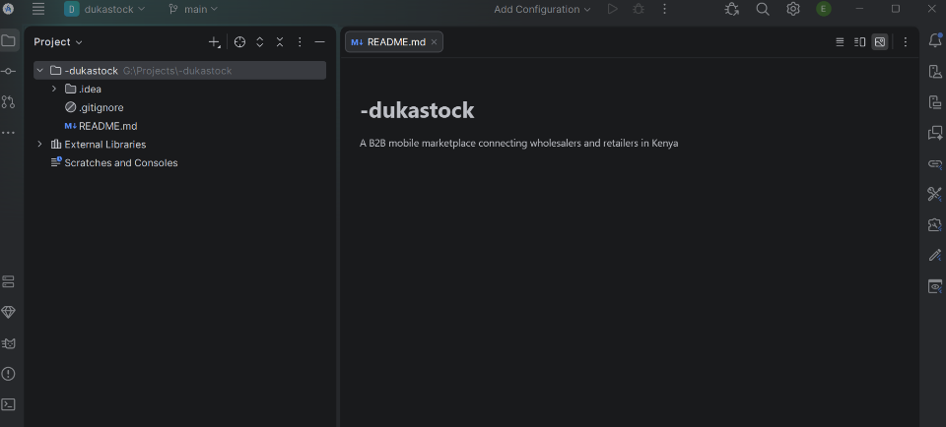

Screenshot 7: Android Studio showing DukaStock project structure and main.dart

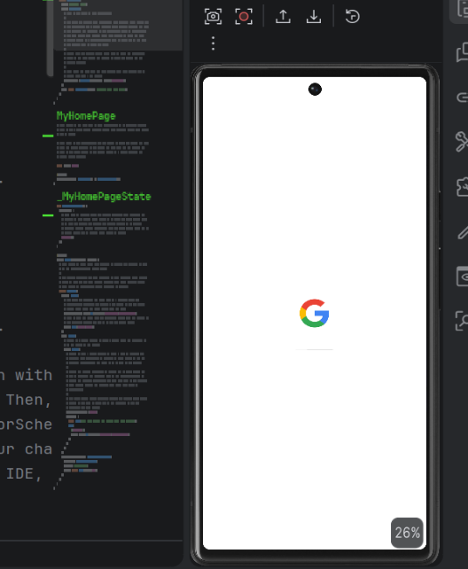

Screenshot 8: Pixel 6 Virtual Device configured in Device Manager

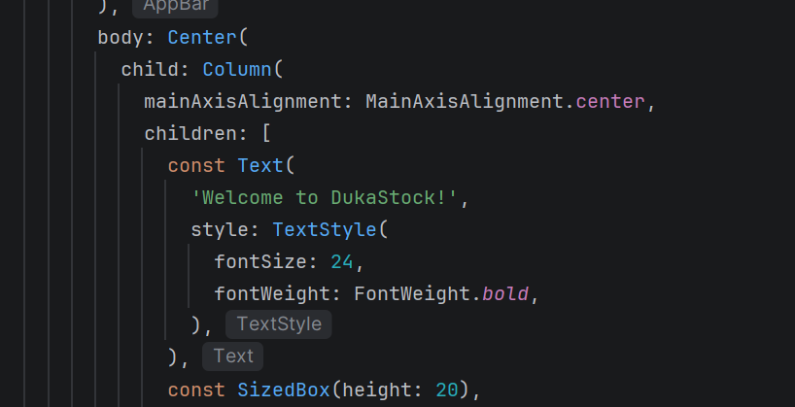

Screenshot 9: Customized main.dart code in Android Studio

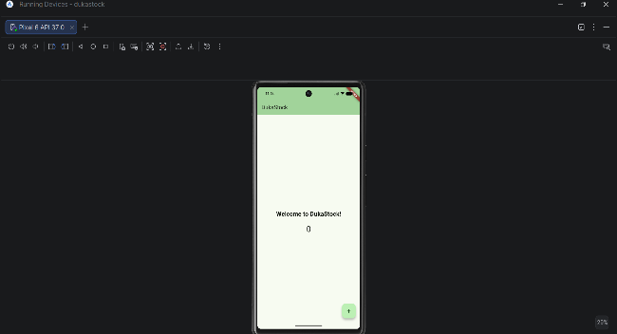

Screenshot 10: DukaStock running on Pixel 6 emulator — green theme visible

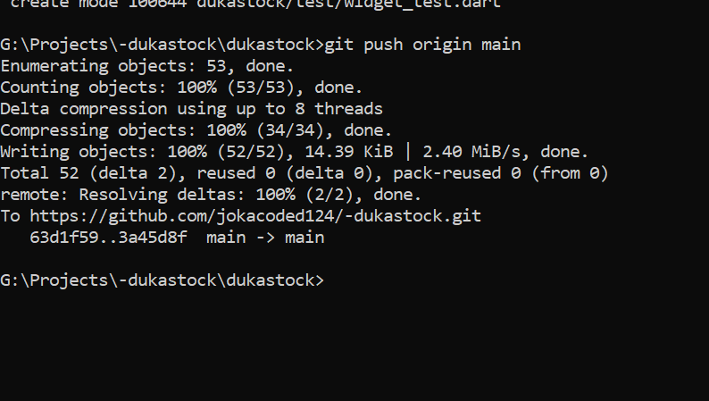

Screenshot 11: git push output showing 53 objects pushed to GitHub

Tools / Software Used

- Android Studio Panda 4 (2025.3.4 Patch 1)
- Git 2.47.0 for Windows
- GitHub
- Flutter SDK 3.44.0
- Dart programming language
- Command Prompt (Windows)
- Android SDK + Emulator
- VS Code

Personal Reflection

This week I set up the full Flutter development environment from scratch. The biggest challenge was configuring the Flutter SDK path and resolving Gradle build errors caused by syntax mistakes in main.dart. I learned that CLI tools are more reliable than GUI wizards for precise project setup

Week 2: Mobile Development Environment — Firebase & Authentication

Practical Activities Undertaken

- Created Firebase project 'dukastock' on the free Spark plan at console.firebase.google.com
- Enabled Email/Password Authentication provider in Firebase Authentication console
- Created Cloud Firestore database in Standard edition with test mode security rules, location: europe-west1
- Registered DukaStock Android app in Firebase with package name com.jokacoded.dukastock.dukastock
- Downloaded google-services.json and placed it in android/app/ folder of the Flutter project
- Added Firebase packages: firebase_core, firebase_auth, cloud_firestore using flutter pub add
- Configured project-level and app-level build.gradle.kts files with Google Services plugin
- Built professional Login screen with email/password fields, show/hide password toggle, and Firebase Auth integration
- Built Registration screen with Full Name, Email, Password fields and visual Retailer/Wholesaler role selector
- Built role-based Dashboard showing different menus for Retailers and Wholesalers based on Firestore role field
- Resolved disk space issue on C: drive (2.78GB free) using MiniTool Partition Wizard to transfer 30GB from G: drive
- Tested full authentication flow on real Redmi Note 14 Android device via USB debugging
- Verified user data saved correctly in Firestore users collection with name, email, role, and timestamp
- Pushed all Week 2 code to GitHub (19 objects pushed)

Screenshots / Evidence Attached

Screenshots Attached: Yes

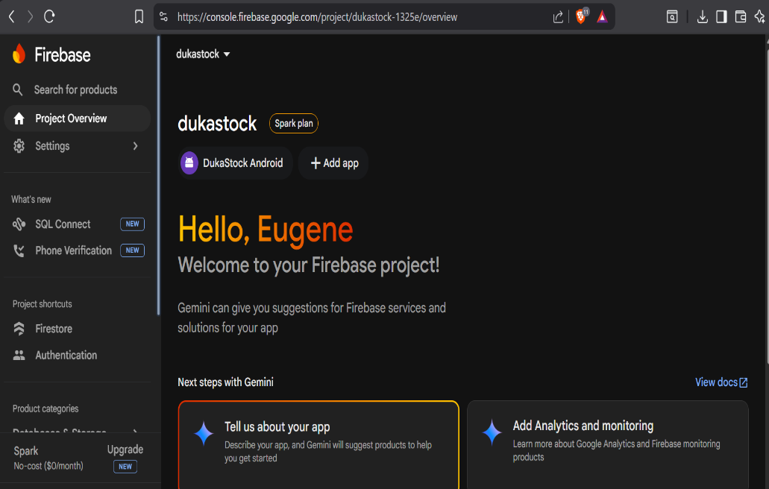

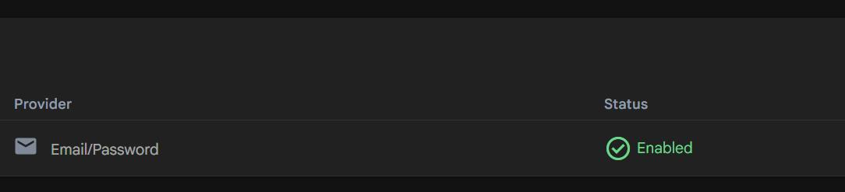

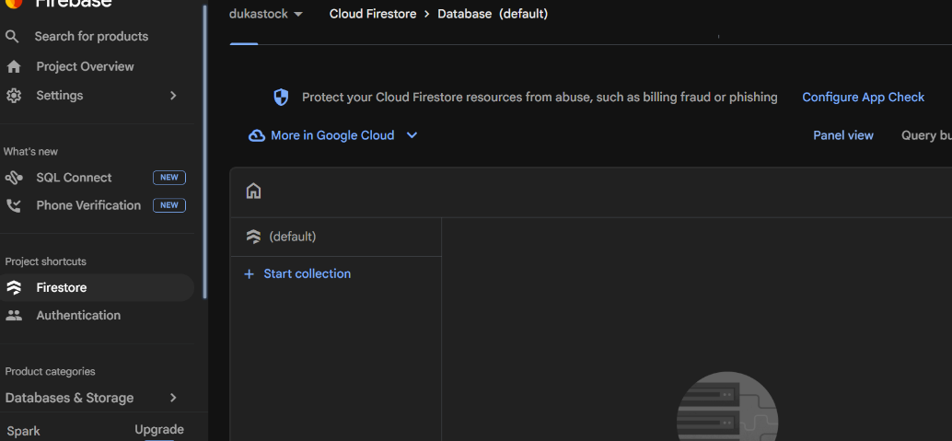

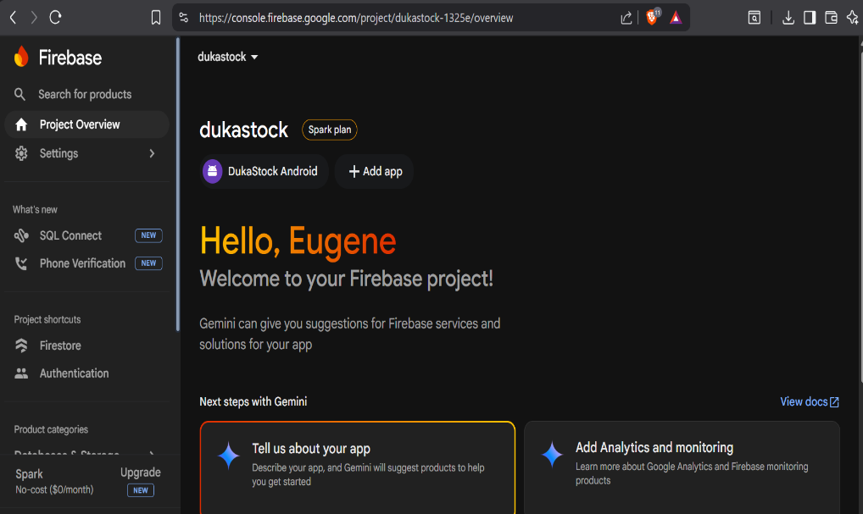

Screenshot 15: Firebase Project Settings showing DukaStock Android app registered

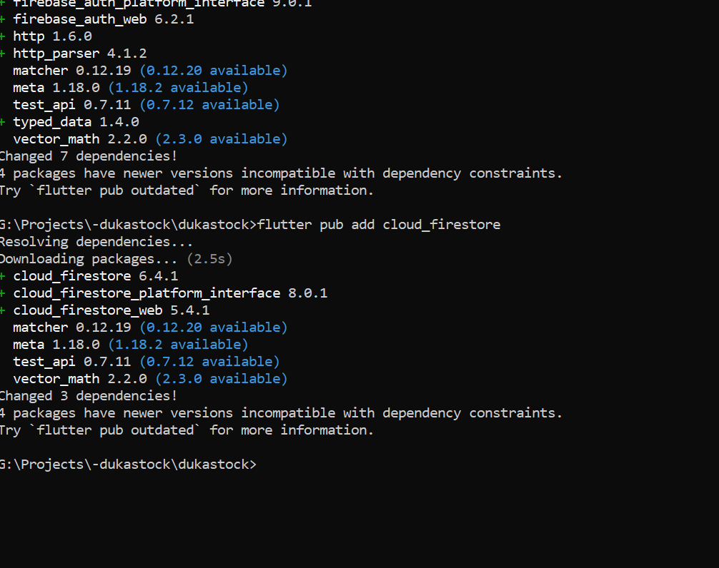

Screenshot 16: Command Prompt confirming google-services.json in android/app/

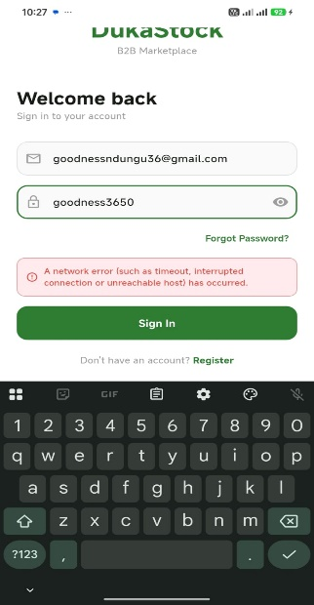
Screenshot 19: DukaStock Login screen running on Redmi Note 14

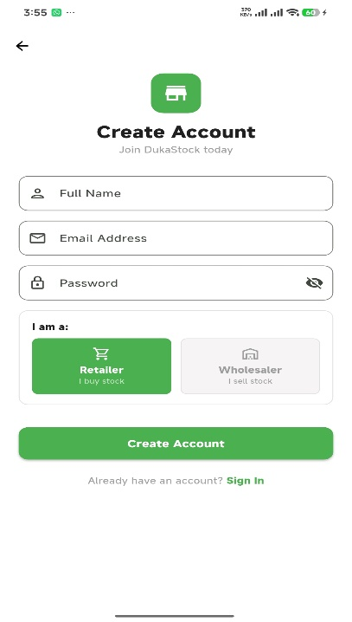
Screenshot 20: DukaStock Registration screen showing Retailer/Wholesaler role selector

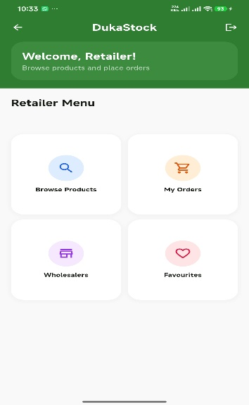
Screenshot 21: Retailer Dashboard — Welcome, Retailer! with 4 menu cards

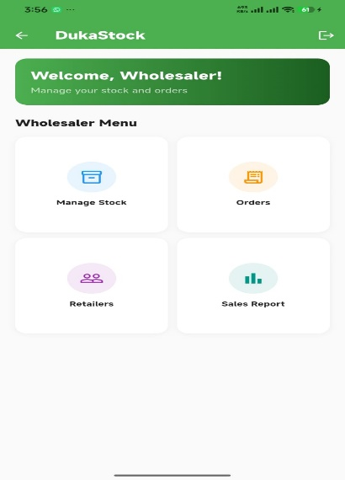
Screenshot 22: Wholesaler Dashboard — Welcome, Wholesaler! with 4 menu cards

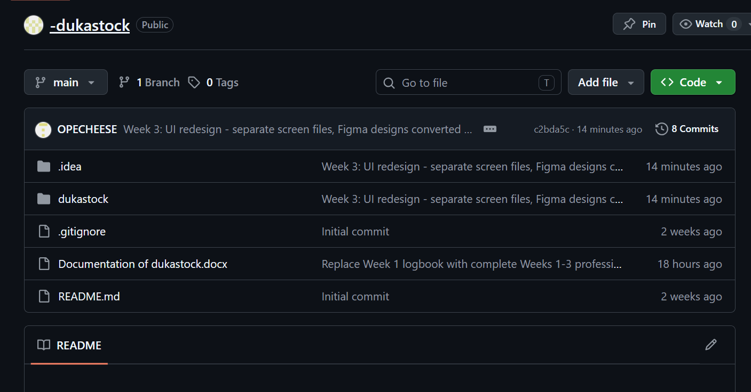
Screenshot 25: git push output showing Week 2 code pushed to GitHub

Tools / Software Used

- Firebase Console (console.firebase.google.com)
- Firebase Authentication
- Cloud Firestore
- Flutter SDK 3.44.0
- firebase_core, firebase_auth, cloud_firestore packages
- Android Studio — Gradle configuration
- Redmi Note 14 — USB debugging
- MiniTool Partition Wizard Free 13.6
- Git + GitHub

Personal Reflection

This week I integrated Firebase into DukaStock and built working authentication. The key challenge was a package name mismatch between Firebase and Flutter which caused a Gradle build failure. I resolved it by registering a new Android app in Firebase with the exact package name from build.gradle.kts

Week 3: User Interface Design

Practical Activities Undertaken

- Created DukaStock UI project in Figma for professional wireframe design
- Designed Login screen wireframe in Figma with DukaStock branding, email/password fields, Log In / Register tabs, and green button
- Designed Register screen wireframe with Full Name, Email, Password fields and Retailer/Wholesaler role selector tabs
- Designed Reset Password screen with new password and confirm password fields
- Designed Retailer Dashboard wireframe with green app bar, welcome banner, and 4 menu cards grid
- Designed Wholesaler Dashboard wireframe with different role-specific menu cards
- Designed Product Catalog screen with search bar and product listing cards
- Converted Figma Login design to Flutter code with improved UI components
- Converted Figma Register design to Flutter code with visual role selector cards
- Added form validation for all input fields — empty field checks and email format validation
- Implemented page transition animations between screens
- Tested all screens on Redmi Note 14 and verified navigation flow works correctly
- Pushed all Week 3 UI improvements to GitHub

Screenshots / Evidence Attached

Screenshots Attached: Yes

📸 INSERT SCREENSHOT HERE
Screenshot 26: Figma workspace showing DukaStock Login screen wireframe

📸 INSERT SCREENSHOT HERE
Screenshot 27: Figma workspace showing Register screen with Retailer/Wholesaler selector

📸 INSERT SCREENSHOT HERE
Screenshot 28: Figma workspace showing Reset Password screen

📸 INSERT SCREENSHOT HERE
Screenshot 29: Figma workspace showing Retailer Dashboard wireframe

📸 INSERT SCREENSHOT HERE
Screenshot 30: Figma workspace showing all 5 screens side by side

📸 INSERT SCREENSHOT HERE
Screenshot 31: Improved Login screen running on Redmi Note 14

📸 INSERT SCREENSHOT HERE
Screenshot 32: Improved Register screen with role cards on Redmi Note 14

📸 INSERT SCREENSHOT HERE
Screenshot 33: Complete navigation flow — Login to Dashboard on device

Tools / Software Used

- Figma (UI/UX design and wireframing)
- Flutter SDK 3.44.0
- Dart
- Android Studio
- Redmi Note 14 — real device testing
- Git + GitHub

Personal Reflection

This week I designed all DukaStock screens in Figma before writing code — a professional workflow. Translating Figma designs to Flutter required careful attention to spacing, colors, and component structure. I learned that designing first saves significant coding time by eliminating guesswork

